**Scoil Réalt na Mara Health and Wellbeing Policy:**

This policy was prepared on behalf of and in consultation with the Scoil Réalt na Mara staff, pupils, parents and the Board of Management.

**Our Vision:**

​

Through teamwork, respect, caring concern and inclusion of each person we in Scoil Réalt Na Mara N.S learn, discover and grow

​

**Our Mission:**

​

Working happily together, we achieve our goals.

**Rationale for the policy:**

It is the goal of the Department of Education that all schools will have developed a Wellbeing Promotion Process. This policy has been introduced to ensure the school is responding adequately to the changing and diverse needs of each of our pupils.

The following definition of Wellbeing aims to take account of its multi-dimensional nature (World Health Organisation (WHO), 2001):

“*Wellbeing is present when a person realises their potential, is resilient in dealing with the normal stresses of their life, takes care of their physical wellbeing and has a sense of purpose, connection and belonging to a wider community. It is a fluid way of being and needs nurturing throughout life.”*

Schools play a key role in developing and enhancing young people’s wellbeing as they spend a large proportion of their time in school during their formative years.

**Wellbeing protective and risk factors:**

Risk and protective factors relating to wellbeing promotion have been identified. Protective factors have been found to promote positive outcomes for children and young people,

In the school/educational setting wellbeing protective factors include:

• positive relationships with peers and teachers - including positive teacher classroom management strategies and a sharing of positive behaviour management practices with parents

• a sense of belonging, security and connectedness to school through a positive school climate and participation in school and community activities

• opportunities for social and emotional learning including the development of attention and planning, self-awareness, self-management, relationship and responsible decision-making skills (CASEL 2015)

• opportunities for the development of knowledge and skills providing a sense of mastery and self efficacy (Shonkoff et al, 2015)

• fostering expectations, recognising contributions, effort and achievement and providing opportunities for success

• wellbeing of school personnel

• protocols and support systems that proactively support children and their families should difficulties arise

• opportunities to develop the necessary skills to cope with using online technology in a safe and appropriate way

• opportunities to develop skills to manage stress that may be linked to school work

In the school setting wellbeing risk factors include:

• disengagement, absenteeism, isolation and alienation

• violence/aggression, bullying and relationship difficulties

• low achievement/learning difficulties/special educational needs including social, emotional and behavioural needs

• cultural differences

• school transitions

• poor connection between family and school

• harsh and inconsistent discipline

• lack of opportunity to develop social and emotional learning, including problem solving and coping skills

**Whole School Approach - Four Key Areas Wellbeing Promotion**

The Department considers the following four areas as key areas for action in wellbeing promotion: • Culture and Environment • Curriculum (Teaching and Learning) • Policy and Planning • Relationships and Partnerships

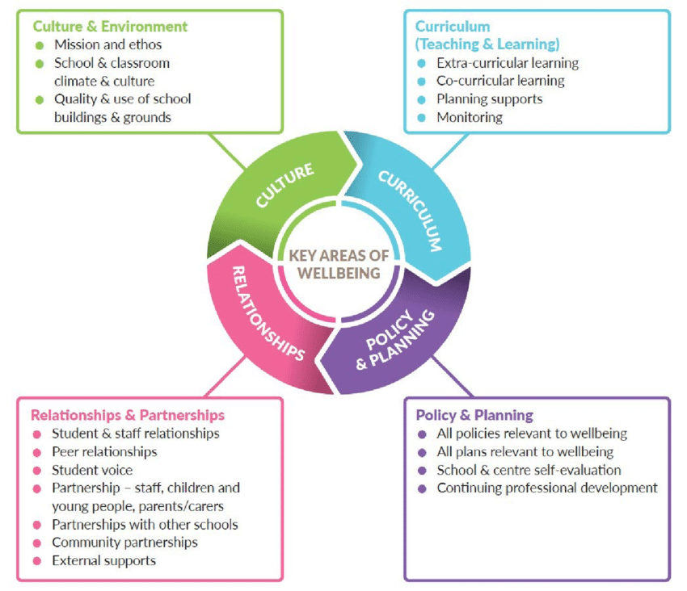

**Wellbeing Promotion:**

**Scoil Réalt na Mara provides a two-tiered support to pupil well-being:**

1. **Whole School Approach**
2. **Individual Support through School Support Team**
3. **Whole School Approach:**

In Scoil Réalt na Mara, we adopt a preventative, multi-component, whole school approach to the promotion of wellbeing. A whole school approach involves all members of the school community engaging in a collaborative process of change to improve specific areas of school life that impact on wellbeing. Adopting a whole school approach has been found internationally to produce a wide range of educational and social benefits for individual children and young people, including improved behaviour, increased inclusion, improved learning, greater social cohesion, increased social capital and improvements to mental health (Weare & Gray, 2003).

**Current Whole School Wellbeing Initiatives in Scoil Réalt na Mara:**

1. Amber Flag—the school was awarded the flag for Mental Health in March/April 2020.
2. Kindness Week in September: helps pupils to connect with others and build meaningful relationships through random acts of kindness, making kindness posters, reading stories based around kindness (“How to fill a bucket” and “Each Kindness”)
3. Themed Monthly Assemblies—all classes come together to celebrate a particular theme at the end of each month. The children are given an opportunity to show off some artwork, project work, songs and poems which they have been working on in class.
4. Music/Drama: Our annual Christmas concert gives pupils the opportunity to display their talent. This whole school event is always full of fun and promotes wellbeing in all.
5. Subject weeks: help to build positive relationships (e.g. Maths week), improve self- esteem and develop transferable skills. They contribute to the wellbeing of the students by giving them the opportunity to learn in many ways. By interacting with their classmates and teachers, and by taking part in activities inside and outside the classroom, each student is challenged to problem solve outside of their comfort zone promoting positive supportive relationships within the school.
6. SPHE: the children take part in a variety of programmes to promote wellbeing—Stay Safe & RSE (all classes—every second year), Weaving Wellbeing (2nd, 3rd and 4th Class) & Friends For Life (5th & 6th).
7. PE: there is an Active Schools Committee who promote being physically active. An Active Schools week takes place every year in which the children are given an opportunity to take part in a variety of different physical activities.
8. Sports Day & Fun Day—This is held in June of each school year. It involves various sporting activities. The activities are for fun and to encourage all to take part. Physical activity is a very important part of wellbeing.
9. Healthy Eating Policy—the school has a healthy eating policy and takes part in the Food Dudes programme every two years. This programme allows pupils to understand the importance of making healthy food choices.
10. School Tours (all classes)
11. Feel Good Friday—this initiative started in September 2021. On the last Friday of each month, the children bring in a treat from home and take part in various activities: playing board games, watching a movie, etc.
12. Restorative Practise—staff meetings were held with Nuala from the PDST in 2021-2022 to learn how this could be implemented in our school.
13. Wellbeing Wednesday—this was started in March 2022 and each Wednesday the children begin the day with a wellbeing activity such as meditation, exercise, mindfulness colouring, etc.

**Staff Wellbeing:**

Staff at Scoil Réalt na Mara work in a safe and supported environment. Staff have taken part in a recent Staff Wellbeing meeting with Nuala

As a staff we regularly reflect on our own wellbeing and mental health.

The Employee Assistance Service is available to all teachers. Employee Assistance Service: Free-phone confidential helpline 1800 411 057 or text ‘Hi’ to 0873690010 - available 24 hours a day, 365 days a year.

**Wellbeing Related School Policies:**

* Admissions Policy
* Code of Behaviour
* Anti-Bullying Policy
* Attendance Policy
* Data Protection Policy
* Special Educational Needs Policy
* SPHE Policy
* Internet Acceptable Usage Policy
* Child Protection Policy
* Children Safeguarding and Risk Assessment
* Healthy Eating Policy
* PE Plan

**Communication with Parents and Wellbeing of Students**

Parents/Guardians are the primary educators of their children. We value co-operation and contact with parents. The Parents’ Association is open to all parents and meets regularly throughout the school year. They participate in fundraising activities which enhance the teaching and learning and wellbeing of the students. The Parents’ Association newsletter is sent home to each household, detailing the recent activities being undertaken in the school.

Other Ways in which the school provides support to parents re: students wellbeing:-

* Parent Teacher Meetings each November.
* One on one meetings when requested with the class teacher/SEN teacher.
* IEP meetings held three times yearly—October, February & June.
* Facilitate meetings with outside agencies.

1. **Individual and Targeted Support:**

We use the Continuum of Support Framework set out by the Department of Education to identify and support students with additional needs. In line with best practice, the Continuum of Support offers a flexible framework within which schools can address all educational needs, including wellbeing needs (DES & NEPS, 2007, 2010a, 2010b). This involves three levels as set out in Table 1 below:

Table 1: Continuum of Support

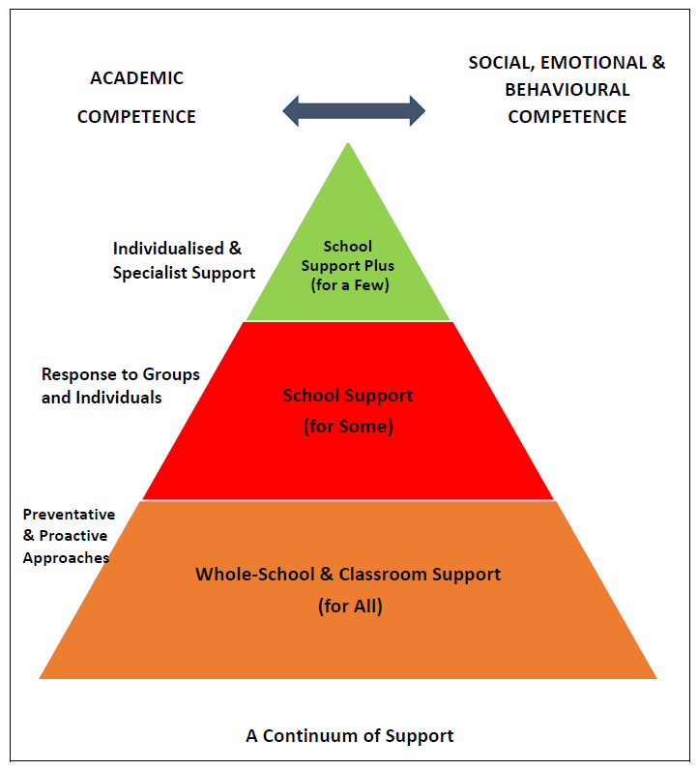

School Support Plus for a Few: Individualised, targeted intervention for children and young people with more complex and enduring needs.

School Support for Some: Identification, targeted prevention and early intervention for those at risk.

Whole School and Classroom Support for All: Whole school support for wellbeing promotion that includes prevention and development of social and emotional competence & coping skills for all.

Depending on the learning needs identified, a pupil with special educational needs may be supported at classroom level or with additional teaching delivered through in-class or withdrawal support models. “Some pupils with more complex and enduring needs may require specific methodologies, teaching approaches and/or learning activities. Such interventions are based on careful identification of strengths and needs, including multi-disciplinary assessment, when necessary. Special education teachers, in consultation with class teachers, plan their interventions carefully to address pupils’ priority learning needs and to achieve the targets identified in the relevant Continuum of Support plan. Short-term planning reflects the Support Plan targets and should break down the development of skills and content into small incremental steps to address each pupil’s specific needs on a weekly basis. Outcomes for pupils are assessed, recorded and used to review progress” (NCSE).

**Indicators of Success:**

In Scoil Réalt na Mara, we use the Wellbeing Promotion Indicators of Success to identify our own strengths and targets for improvement, and to actively monitor our progress and outcomes in relation to wellbeing promotion over time.

These Indicators of Success in the four key areas of wellbeing are further expanded upon as Statements of Effective Practice (See Appendix A) which provide a set of standards for wellbeing practices across the Continuum of Support at the whole school preventative level (Support for All) and also at the targeted and more individualised levels (Support for Some and Few). These Statements of Effective Practice form the basis of the school’s self-reflective Wellbeing Promotion Process. They enable us to identify strengths and areas to target and therefore plan the next stage in the improvement journey. To implement this policy our school is required to use the six-step School Self-Evaluation (SSE) process with the Wellbeing Policy Statement and Framework for Practice, to initiate a Wellbeing Promotion review and development cycle.

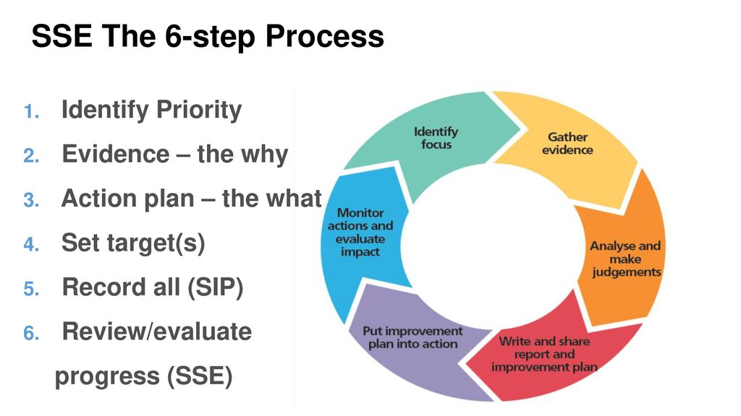

Firstly, a number of questionnaires were disseminated to the staff, parents and pupils of Scoil Réalt na Mara to gather evidence which could then be analysed. These were carried out in March 2021. Our strengths, challenges and opportunities were identified. The analysis informed the actions for wellbeing in the four key areas. The specific key areas prioritised for further development were Relationships and Partnerships, Culture and Environment, Policy and Planning and Curriculum (Teaching and Learning). We will incorporate these actions into our School Improvement Plan (SIP). Actions will be reviewed on an ongoing basis which will assist us in tracking our progress.

**Key Area: Relationships and Partnerships:**

Indicators of Success:

* Children and young people, their parents and other external partners are actively involved in wellbeing promotion within the school community.
* All adults in schools and centres for education have an increased awareness of the importance of wellbeing promotion, including listening to children and young people, and signposting them to internal or external pathways for support when needed.

1. Parents interact with the teachers in a calm and respectful manner, even when there are disagreements.

Actions: The school will build upon and promote positive relationships between parents and staff members. The school will establish boundaries for conversations—meetings between staff and parents can only be held when an appointment is made, the meeting/call is held within an allotted time. Parents will be reminded that if they have any problems, it will first be discussed with the classroom teacher.

1. School management priorities health and wellbeing.

Actions: Provide access to information on supports available to staff members within the school and the community. Staff will regularly reflect together on their own well-being during staff meetings. Staff will be provided with the Psychological Society of Ireland’s 40 tips for mental health, well-being and prosperity. Staff will be reminded of the Employee Assistance Service should they require additional support.

**Key Area: Culture and Environment:**

Indicator of Success:

* Systems are in place so that the voice of the child/young person, teacher and parent are heard and lead to improvements in school culture and ethos.

1. Pupils respect the school building.

Actions: The school building, grounds, classrooms and work spaces, are well maintained and appropriately furnished creating a welcoming, safe and warm environment. Children will be reminded of the importance of looking after school property during an SPHE lesson and using the school Code of Behaviour.

**Key Area: Culture and Environment:**

Indicators of Success:

* Children, young people, and staff experience a sense of belonging and feel safe, connected and supported.
* Systems are in place so that the voice of the child/young person, teacher and parent are heard and lead to improvements in school culture and ethos.

1. My teachers and the principal talk to us in a calm and respectful way, even when there are disagreements.
2. The children are friendly to each other.

Actions: We have started to implement Restorative Practise in our school. Restorative Practise promotes self-regulation, teaches social skills, minimises disruption and improves relationships between and among pupils, teachers, and staff.

**Key Area: Curriculum (Teaching and Learning)**

Indicators of Success:

* Children and young people experience positive, high-quality teaching, learning and assessment, which provides opportunities for success for all.
* Children and young people access curricular activities to promote their physical, social and emotional competence to enhance their overall wellbeing.

1. Our teachers make learning interesting and fun.

Actions: The staff and pupils are currently involved in a number of new initiatives such as Creative Schools, a school Podcast and the BLAST Programme. New interactive whiteboards and iPads were purchased which have enhanced the teaching and learning in the school.

**Key Area: Culture and Environment**

Indicator of Success:

* Children, young people, and staff experience a sense of belonging and feel safe, connected and supported.

1. My school is tidy and bright.

Actions: Artwork by local artist Will Sliney has been put up in the new corridor in the school. The indoor space displays the work, talents and accomplishments of children and young people.

**Key Area: Culture and Environment**

Indicator of Success:

* Systems are in place so that the voice of the child/young person, teacher and parent are heard and lead to improvements in school culture and ethos.

1. My child’s opinion is sought and listened to when deciding upon school policies and plans.

Action: In devising future school policies and plans, opportunities will be provided for children and young people to have an active voice in decisions relating to school improvement.

Indicator of Success:

* Systems are in place so that the voice of the child/young person, teacher and parent are heard and lead to improvements in school culture and ethos.

1. Parents’ views are sought and listened to in school planning and policy development e.g. healthy eating policy, anti-bullying policy and discipline policy.

Actions: Parents will be sent policies and asked for their input if deemed appropriate. Opportunities will be provided for parents to have an active voice in decisions relating to school improvement.

Indicator of Success:

* Children, young people, and staff experience a sense of belonging and feel safe, connected and supported.

1. The layout and design of the yard encourages children to be active.

Actions: Outdoor space is provided to facilitate social interaction and physical activity and quiet time. The children have been involved in planting trees in the yard (An Choill Bheag), there will be a new seating area and sensory garden for the children in the near future. The yard markings—hopscotch, etc.—were painted in the summer of 2021.

Principal:____________________

Date:_______________________

Chairperson of the BOM:________________________________

Date:______________________________